HW 2:

* Play with [https://js.tensorflow.org](https://js.tensorflow.org/" \t "_blank)

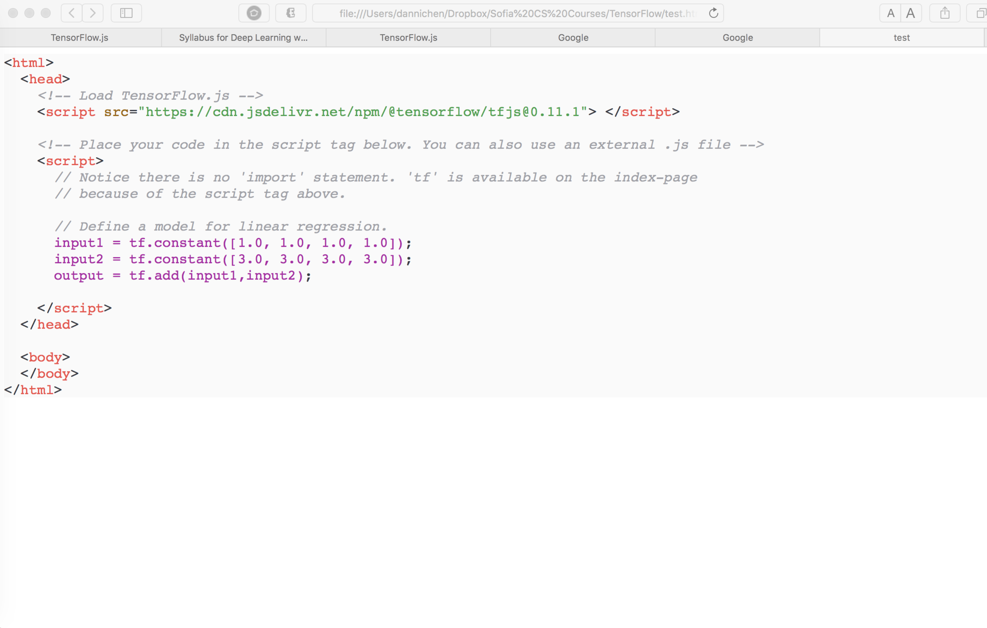

* Study the MNIST Database: [http://yann.lecun.com/exdb/mnist/Links to an external site.](http://yann.lecun.com/exdb/mnist/" \t "_blank)
  + prepare mnist.train: 5,000 data points of training data
  + prepare mnist.test: 1,000 points of test data
  + prepare mnist.validation: 500 points of validation data
* Try data analysis and prediction using the same MNIST data
  + play the data with Jupyter Notebook

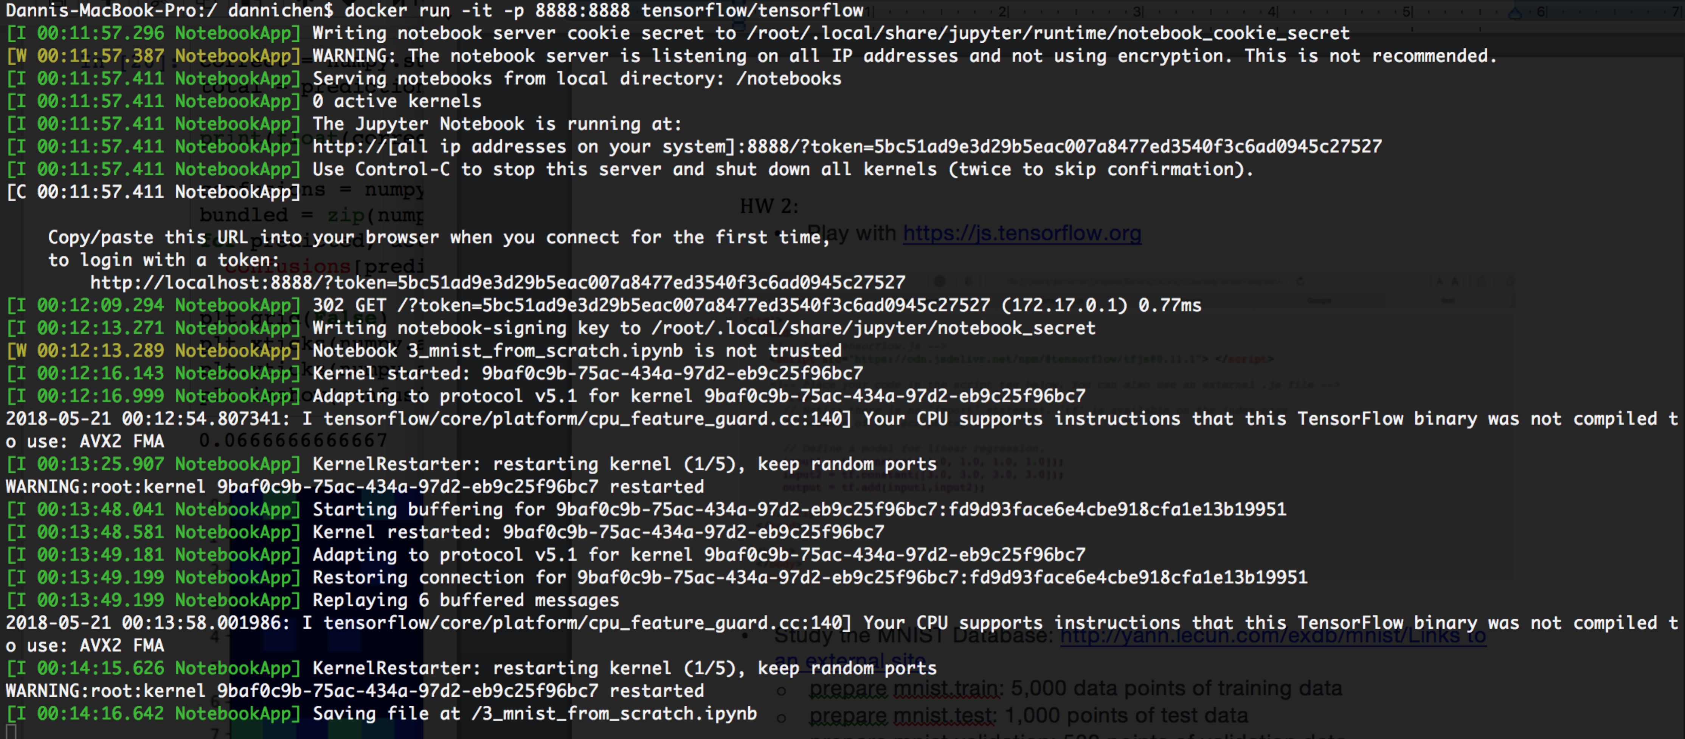

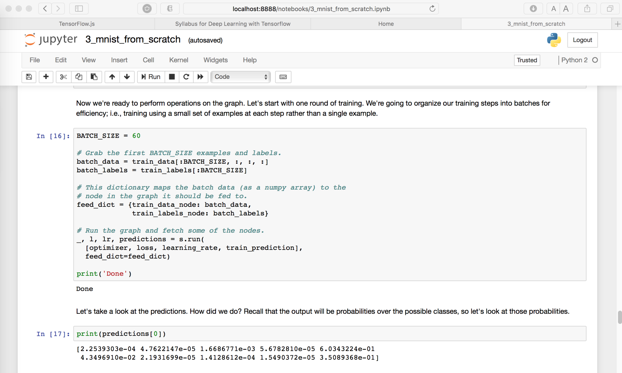

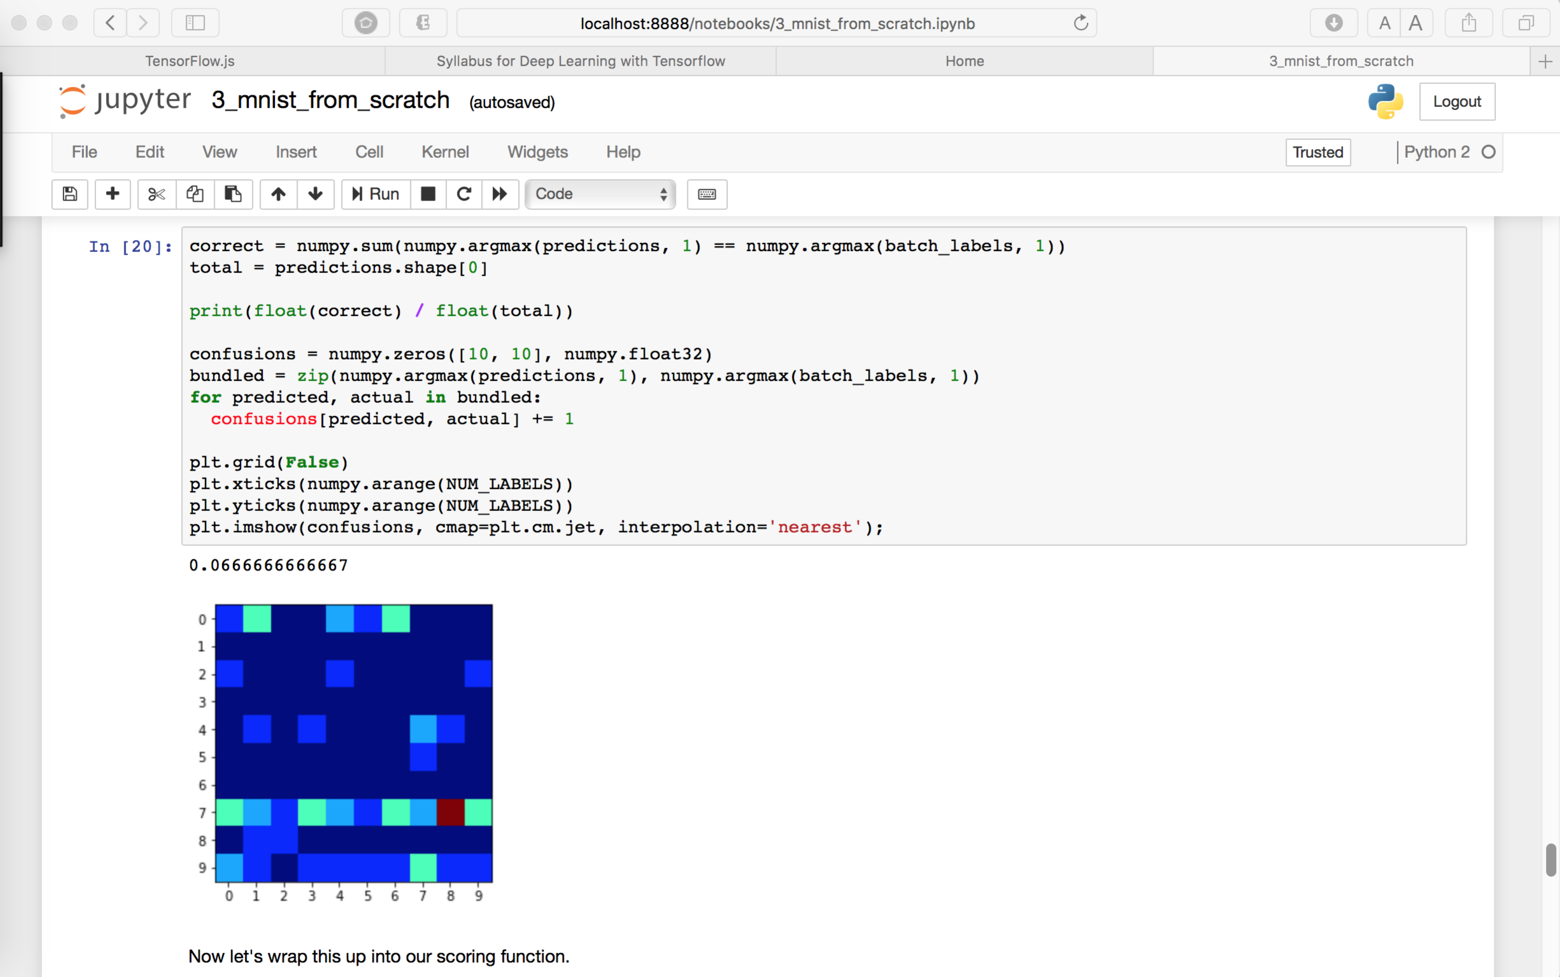

* + play the data with Keras

